Reading a graphic novel

Suggestions for teaching and learning strategies
- Sequencing
Copy a page and cut the panels up so they out of order. Ask pupils to organise the panels in sequence, then justify their choices.

- Lay out
Take a page. Copy and cut the panels as above. Create a blank layout of the panels. Ask pupils to place the panels in the correct place and number the panel boxes. Then ask them to explain their reasoning.

- Blank out
Copy and blank out text boxes and/ or speech bubbles on a page. Ask pupils to write the text in pairs. Then compare with the original page. Ask what was similar/ different.

- Cumulative story
Similar to blank out, but this time ask pupils to write in the first speech balloon and then pass their sheet on to another pupil to write in the next one and so on.

- Predicting
Pause and ask pupils to create the next panel to show what happens next.

- Picture detectives
Select an intriguing and rich image. Copy and stick in the centre of a large sheet of paper. Ask pupils to annotate in three different colours: a) emotions/ feelings b) description ‘what they see/ know’ and c) inference ‘what they think’)

- Summarising
Ask pupils to list the 6 main events in the section they have read. Alternatively they could represent the key events visually and then explain what each image/ object represents.

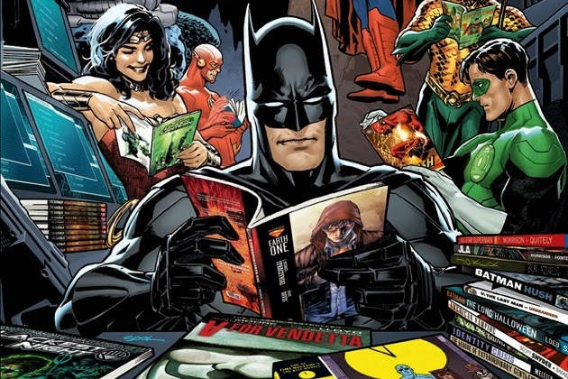
- Sound effects
Ask pupils to collect examples of sound effects (eg clunk, squelch, grrrr), say what makes the sound and how it adds to the pictures and text.

- Camera angles
Select some panels with interesting camera angles/ perspectives. Introduce pupils to key terms: extreme close-up, close up, long shot, mid shot, short shot, high angle, eye-level, low angle, bird’s-eye view
http://www.mediaknowall.com/camangles.html
In groups of three ask pupils to re-create one of the panels and take a photo. Compare the original panel with the photo recreation. As pupils to explain the effect of the choices.

- Post-it summary
Ask pupils to identify 4 key panels that show the most important events of the section they have read. They should stick a post-it on the panel and write on it to say why this is important.

- Different points of view
Give each group of pupils a different character and ask them to prepare the story from their perspective. Use drama techniques such as hot-seating, forum theatre, role-play. Ask pupils to re-create one section of the novel from a different character’s point of view.

