The language of written explanations.
Sort the cards into statements and causal explanations
Cards
Wind direction is shown by wind vanes and wind socks. | After a lunch of burger and chips, the children had only a few apples left to sell.
We should also save rainforests because they release so much water into the air that they affect the climate of the tropics. | Kids were playing football, skateboarding and just hanging around.
The river flows around these in hundreds of smaller channels forming a huge delta. | Wulfric sat alone in his hideaway on an island in the Somerset marshes.

Causal Explanation
Diagram as additional resources to film sequences of sharks

Dorsal fin
The Features of a Shark
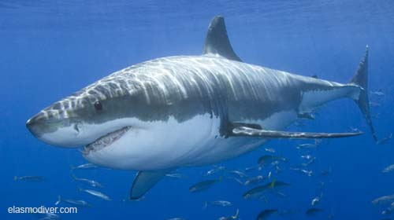
Powerful tail
fins
Streamlined body

Good sense of smell

Sharp teeth

Fishbone chart
It has………….. so……….. It has………so……… It has…….so………….
Why is a shark a successful ocean predator?

It has……………so……. It has…………so……….. It has…………so………..
Work in pairs. Decide how each characteristic helps the shark and record these at the end of the bones It has......................so.....................
Cause and Effect table for structuring a causal explanation
 | Characteristic |  | Cause |  | Effect
Intoduction  One reason  Another reason  In addition  Furthermore  Finally  As a result | The shark is a successful ocean predator  the shark can…… | because  as | has……features  has (feature)………  has(feature)………  has(feature)...…….  has(feature)……….  has(feature)………..  so  therefore  this means  as a result |  | it can………….

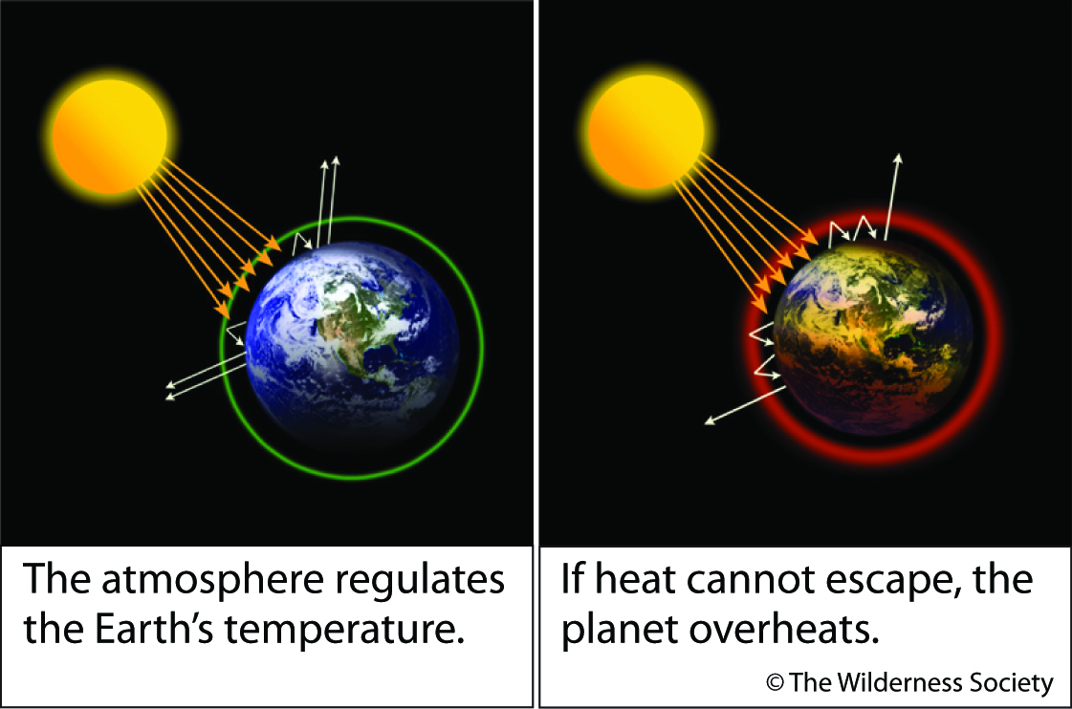
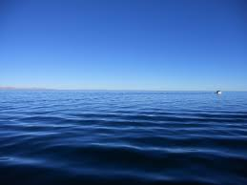
1. 2.

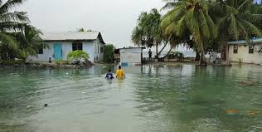
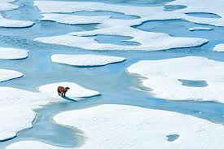
3. 5.

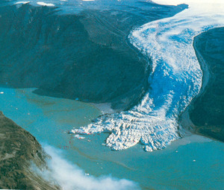
4.
The Rising Sea
6.

Ask pupils to brainstorm words and phrases associated with each picture in turn followed by the headin
Dictogloss Activity
Causal Explanation from class topic Weather and Climate
The Rising Sea
Global warming is making the sea levels rise. In the last hundred years, they have risen by up to 25 centimetres. Scientists think the sea will keep on rising.
When water gets warmer, it takes up more space. When the seas warm up because of global warming, the sea levels rise. The ice sheets in Antarctica are melting and so are the glaciers on the mountains. The extra water from the melting ice goes into the sea. When the sea levels rise, the sea can flood the land near it.
Read the text twice to the pupils.
Ask them if there are any words they don’t know.
Read a third time.
Pupils record key words for each sentence across the page.
Pupils in pairs reconstruct sentences from key words.
Writing process explanations

Sort the cards into two groups

Causal Explanation | Process Explanation

A camel has long eye lashes so that it can stop the sand going in its eyes. | He shouted at the top of his voice because he was lost in the woods. | After that the clouds become heavier which leads to rainfall.
Secondly, you need to sieve the flour so that there are no lumps in the mixture. | A tiger has stripes to help it camouflage itself in the forest, amongst the trees. | These vans take the milk from the dairy to peoples’ homes.

Table for structuring process explanations
Introduction:…………………………………………………………

First stage effect

Second stage effect

Third stage effect

Fourth stage effect

Fifth stage effect

Final stage effect

WALT: identify the features of a process explanation text. Listen to/ read text.
Introduction: In many parts of the world rainforests are being cut down. This has serious consequences on the climate.
Trees are cleared away
There are no roots to hold the soil
Less falls as rain
Water drains away quickly
Fewer trees
Less water evaporates
Conjunctions:
Therefore
So
Because
This means/ which means
washes soil away
Rain comes

Chokes them with mud
Soil washes into streams and rivers

Water isn’t cleaned and cleared.
Water plants and animals die.

drought
Less water

Concluding sentence:
Due to drought less crops will be produced and other plants won’t grow, so the drought will continue.

